

Excel and Tableau Project

Task 1 Data

Policies and Procedures

The first part of your assignments will be to outline what policies need to be adhered to when working with data.

You are going to be working with ‘The Wealth of nations’ data. Investigate by researching the internet or looking back at your notes to tell us what and why these policies need to be adhered to while you are using this data. Also tell us why it is important to be aware of these rules as a data analyst .

Data governance policy, Data collection and storage, Data access and use, Data security, Data privacy and confidentiality, Data sharing and reporting.

This policy is used for any organization managing their data. By adhering to this policy you would gain better influence within the organization, gaining trustworthy data, the idea is to rid poor quality data from coming into the organization. The policy also benefits from Data Democratization this means using centralized data hubs can help the team to gain better and quicker access to these data. With regulatory compliance it helps to avoid misusing sensitive data in addition without this beneficial policy it could lead to damage the organizations reputation and support along with a fine.

By adhering to this policy, you avoid getting legal penalties. It helps and maintains the accuracy and reliability of data gaining high integrity. adhering to the security and privacy credentials allowing to protect sensitive information, avoidance to misuse and data breaches saving both the user and organizations alike. Trust and Reputation has a use of its own by building trust with customers, partners, and stakeholders by demonstrating a commitment to data protection and ethical practices. Operational Efficiency is proficient to avoid redundancies and improving efficiency and manages huge data. Risk management reduces the likelihood for data breaches and has strong and efficient way to handle data.

Data access and use

Data security

Data privacy and confidentiality

Data sharing and reporting

Task 2 Excel

1. Setting up password

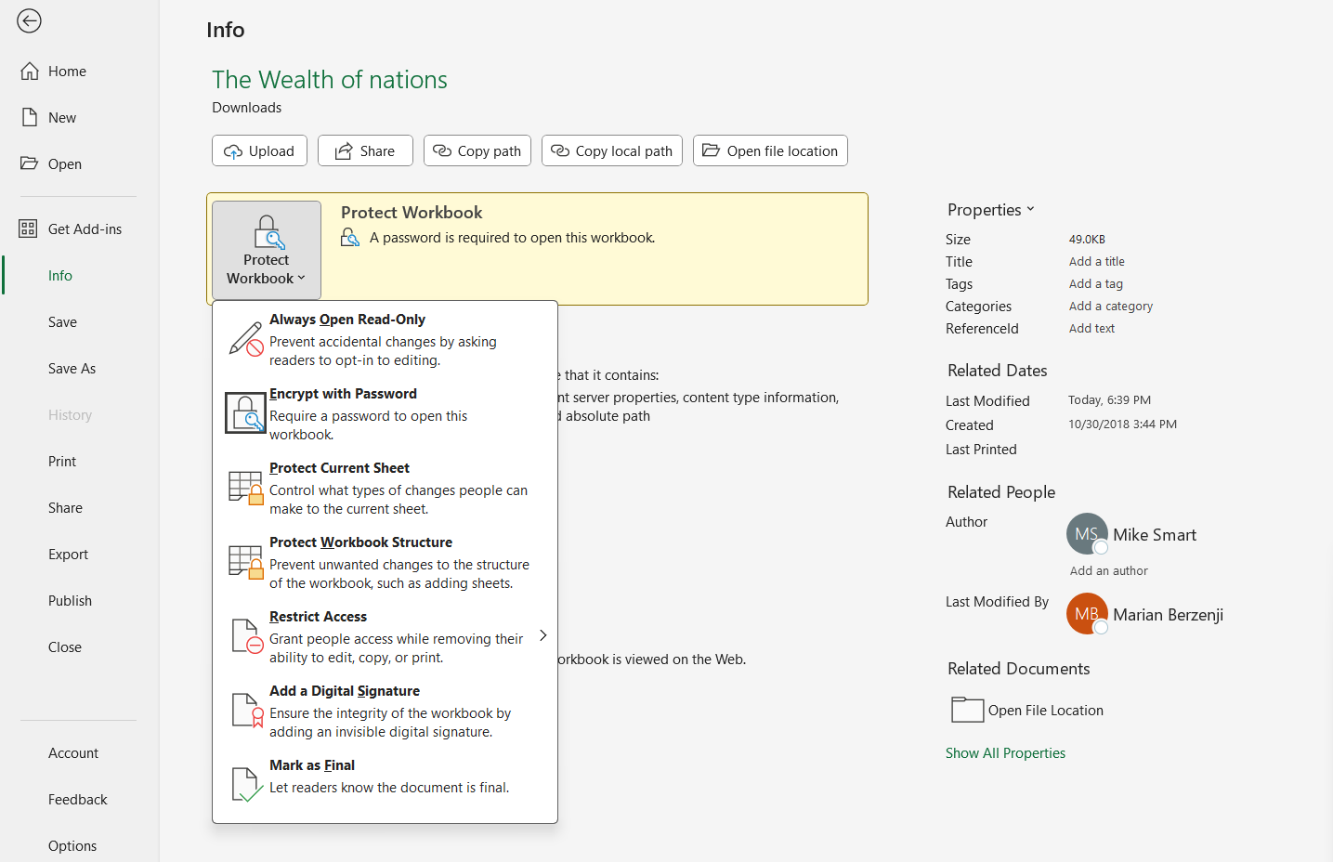

To protect the workbook select file, select info, select protect workbook, select encrypt with password, enter password, reenter password, lastly save the workbook.

1. Highlight column C and change the data to display in British Pound symbol

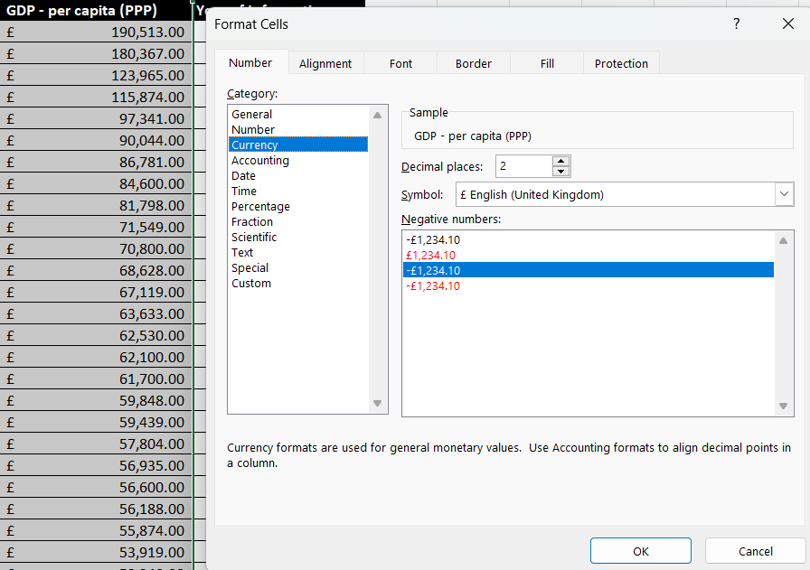

To change the column to GBP symbol you highlight the column, click the dollar symbol on the home tab and change it to GDB, or you could highlight column, right click, select format, select currency, select symbol and change it to GBP English (UK).

1. Turn the GDP sheet into a table

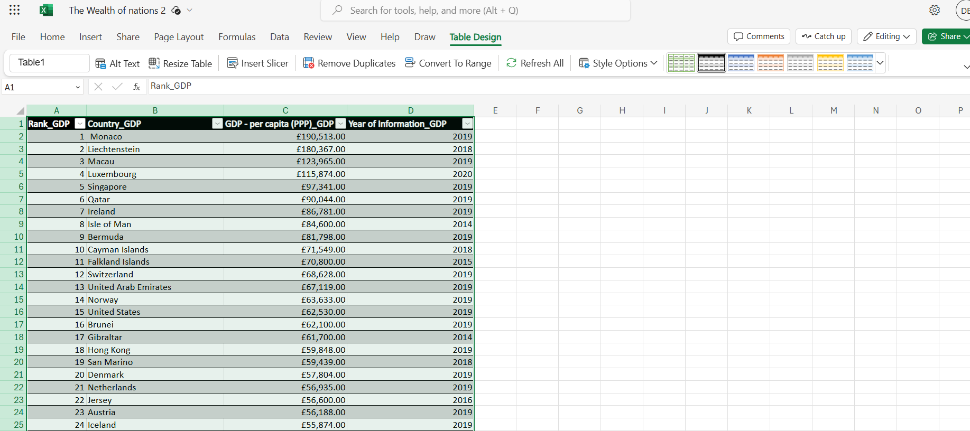

Highlight the range of the table, click on the ‘table design’ ribbon tab, select convert to range to avoid affecting the existing table, now select the insert ribbon tab and select table, ensure you have the correct range, check the box for my table has headers and click ok.

1. Filter the table to display only the information for 2019

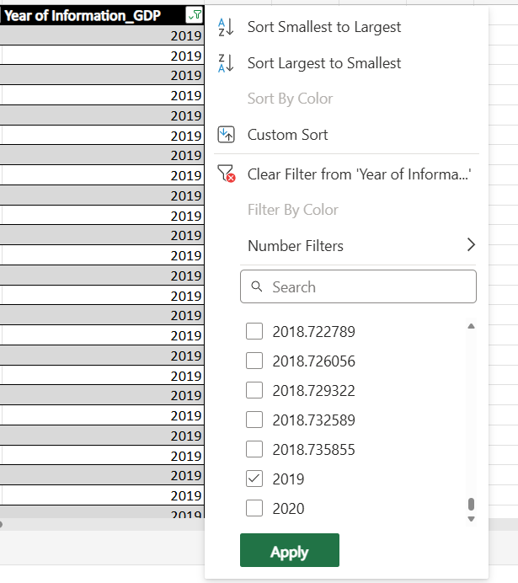

To filter table to allow only display the year 2019, you must click the filter drop down box shown by the orange arrow, check the select all box to uncheck everything, scroll down for 2019 and check the box.

1. Next create a chart that will only display the following data ‘Rank, Country and GDP - per capita (PPP). The chart can be anything as long as it is suitable.

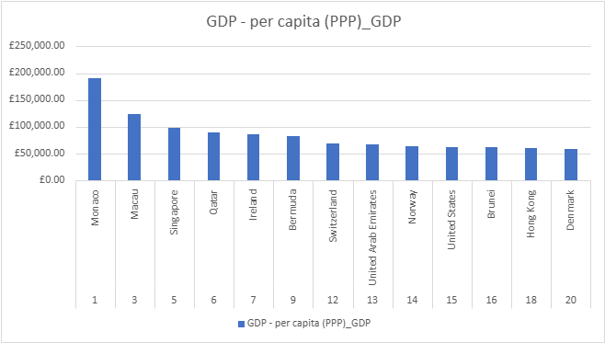

6. Using your creative skills edit the chart

1. Add a title b. Add X and Y Axis labels c. Make the Chart Visually Pleasing.

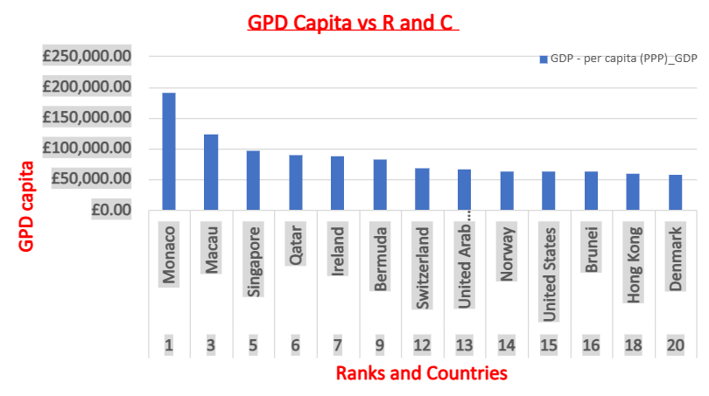

To add a Title go right click format and add title by sliding the Chart Title, to add X and Y axis again need to right click for format and slide the slider to add a title, before that you must scroll down for Horizontal for X axis and vertical for Y axis, to make it visually pleasing you must colour it make it bold and usually for titles you underline it.

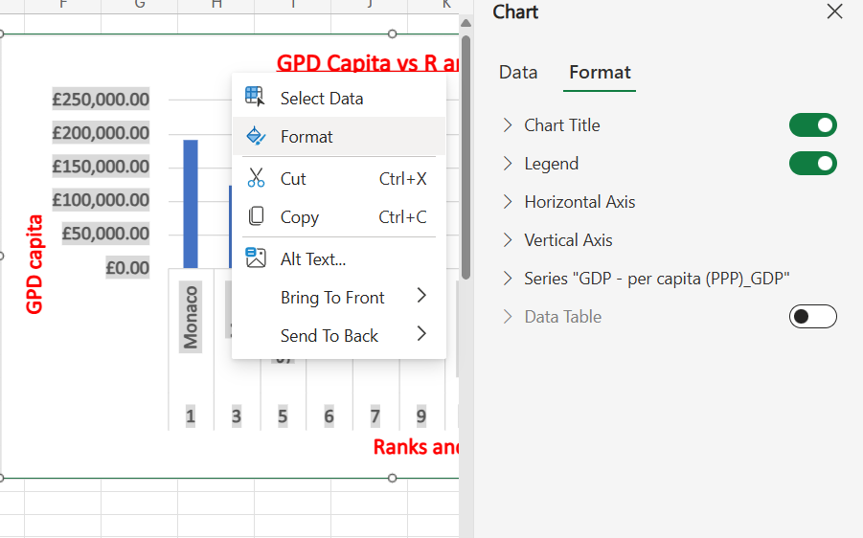

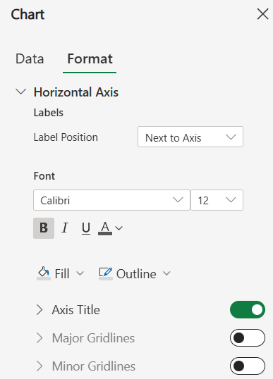

7 move the chart to a new sheet and add a suitable name

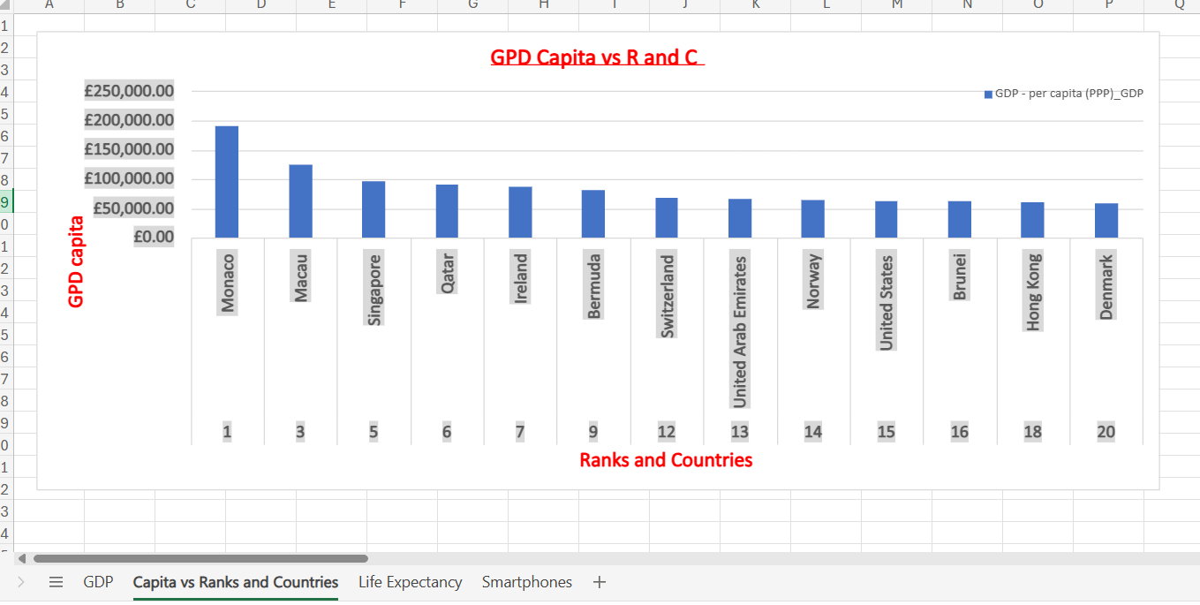

8. Create a sort for the top 20 highest ranking counties

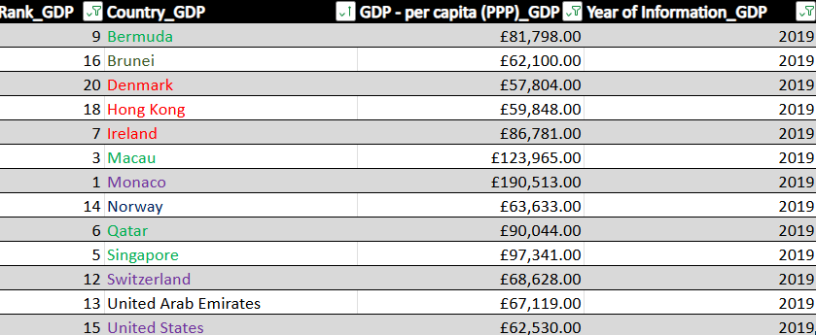

Sorted by Desc and colour automatic.

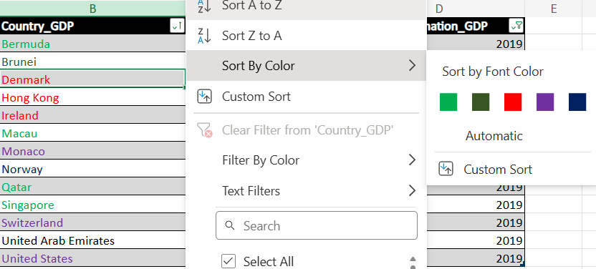

9. Next create a new Bar chart to display the 20 highest ranking countries from your sort and then move the chart to be underneath the table, as shown below.

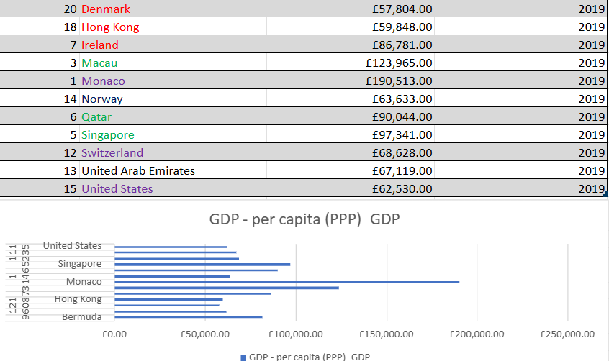

The sort DESC is applied to the new bar chart and added below.

10. Colour the background by highlighting the area underneath the table as shown below. Find the add a fill colour icon and select a colour.

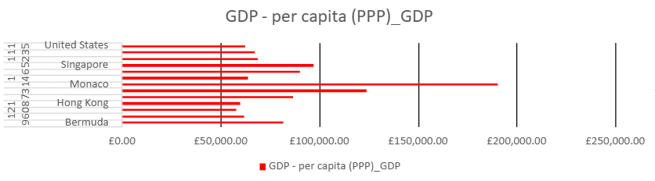

Task 3

1. Import data to import data drag and drop onto the field

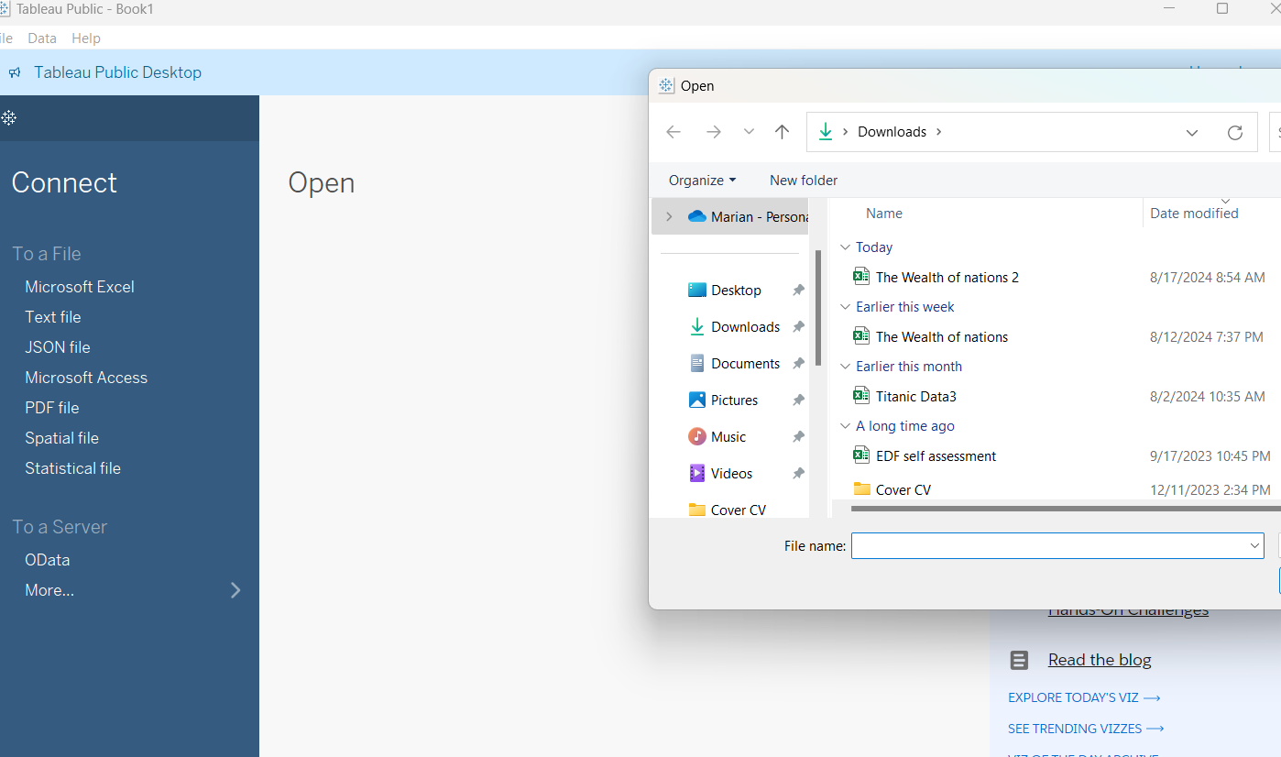

Drag and drop indicated by the arrow

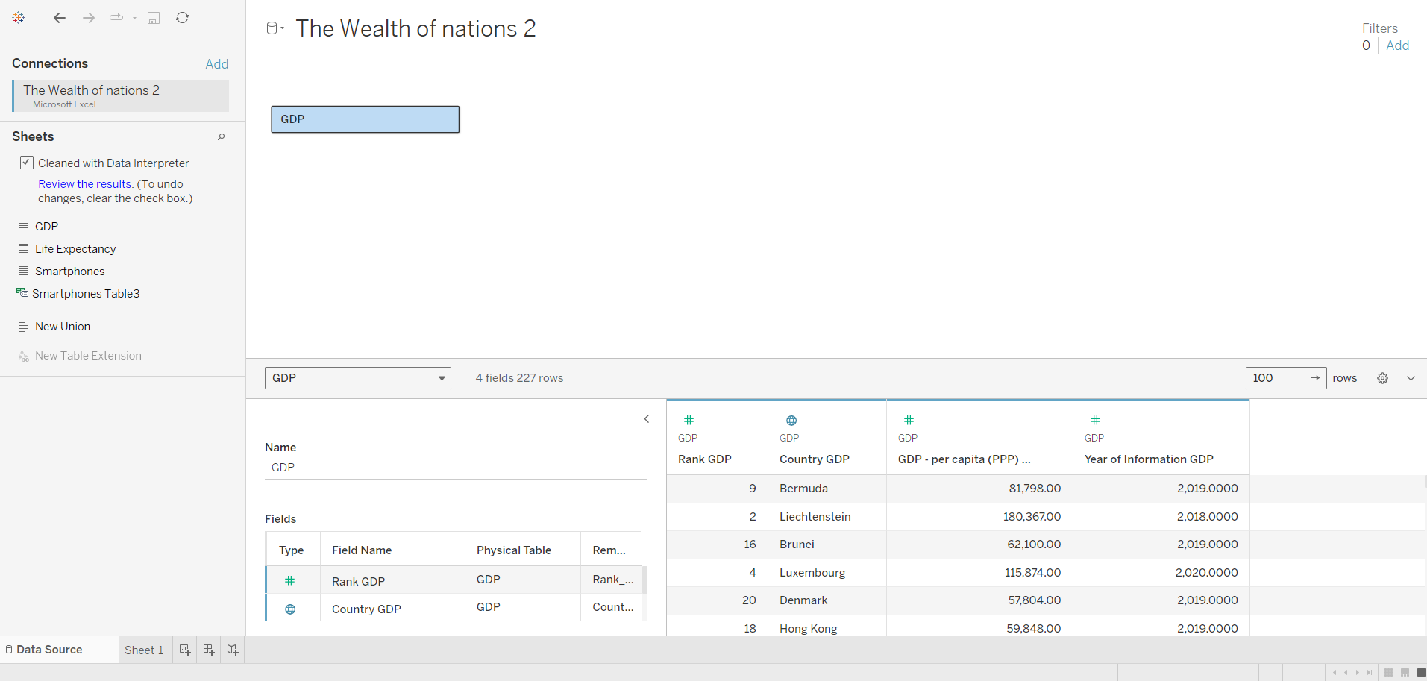

1. Set relationships

For all of them set a country to country relationship using the drop down arrow indicated by the encircled box.

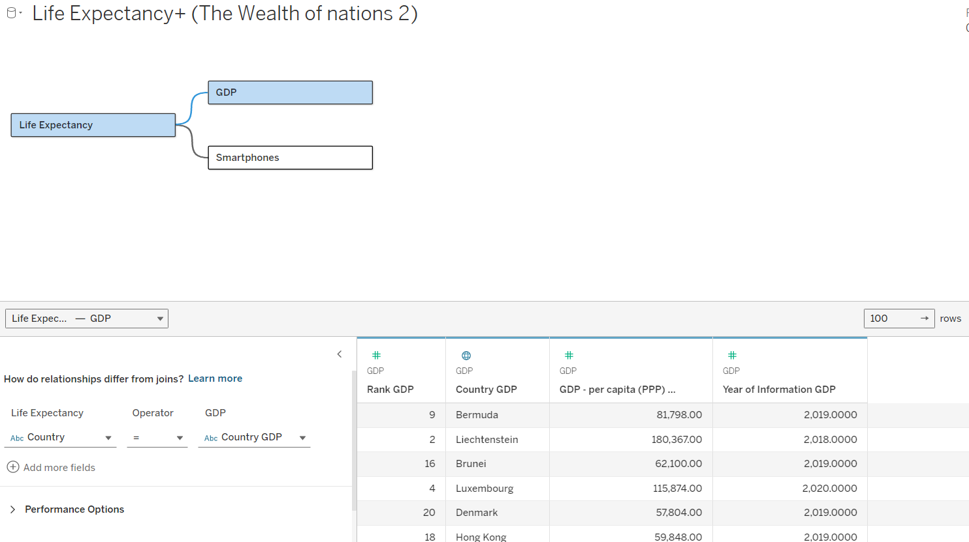



1. Check data types.

Compare the data set between excel and tableau and change accordingly example would be the year of information column change it to string and back to whole number fixes that issue.

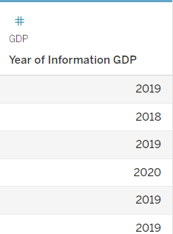



1. Build charts

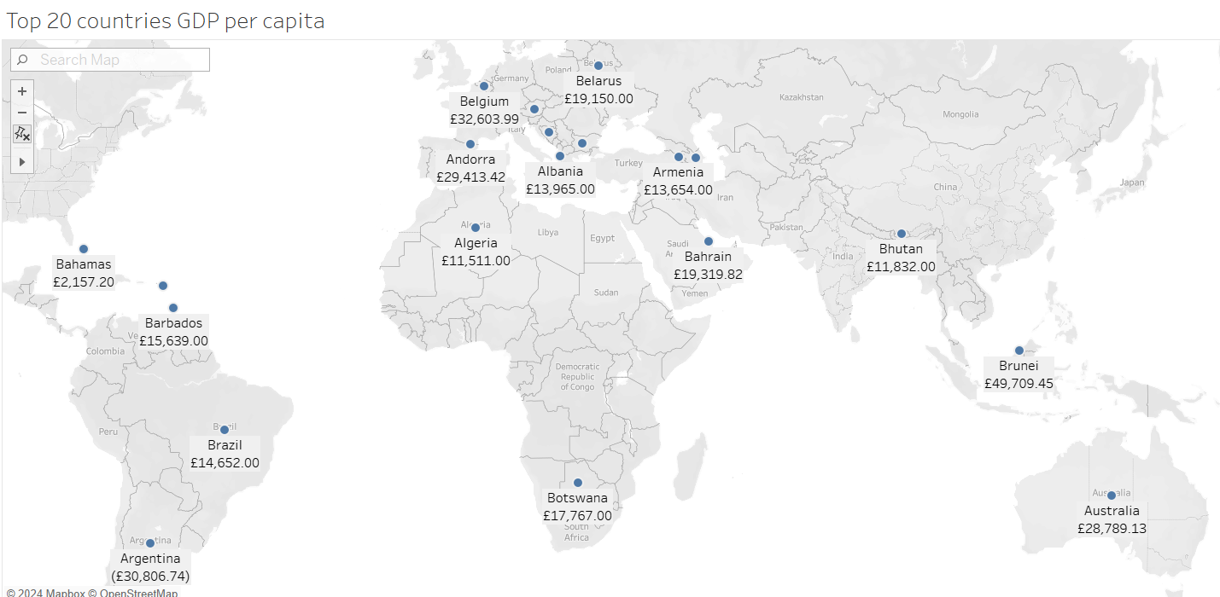

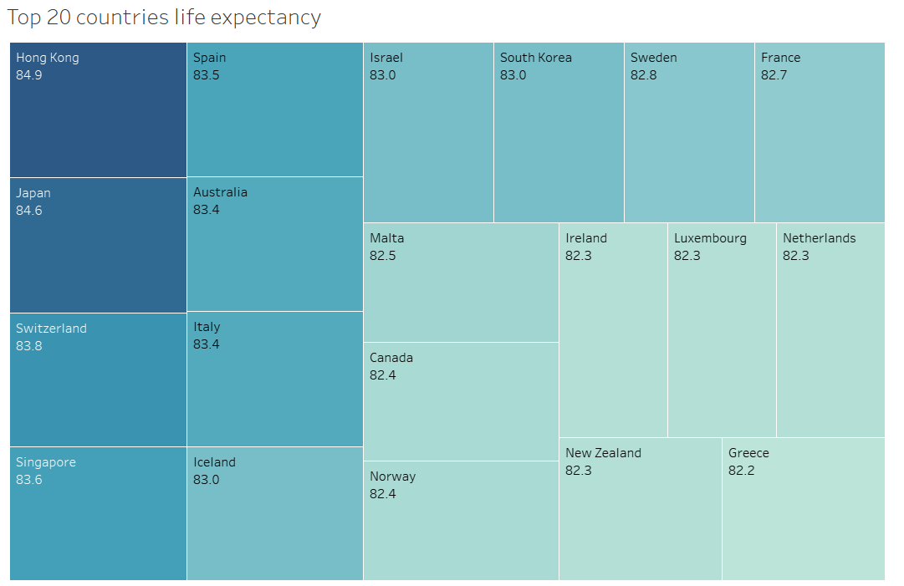

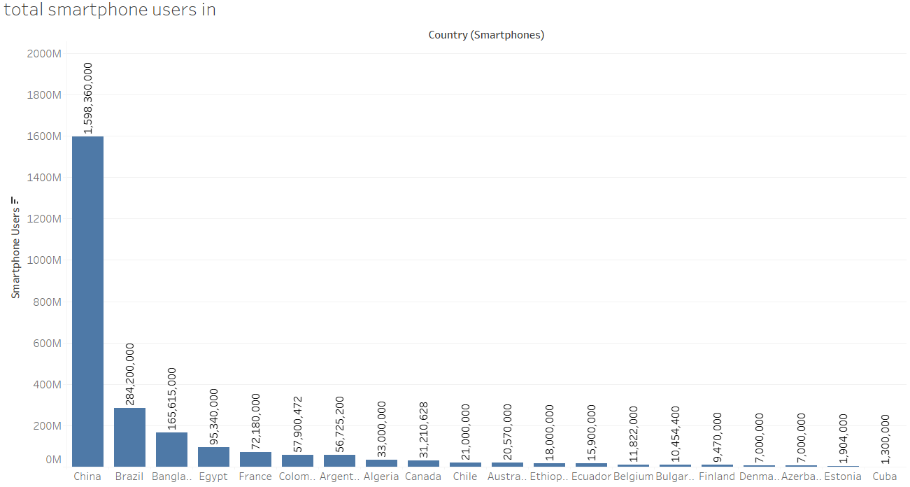

Client Requirements

The client is colour blind and requested you to bear this in mind when building your dashboard. The client is only interested in the top 20 highest ranking countries. All your visuals should be for the top 20 highest ranking countries.

1. As you create your charts, if you see a little grey box containing a count of null values, select the filter option.

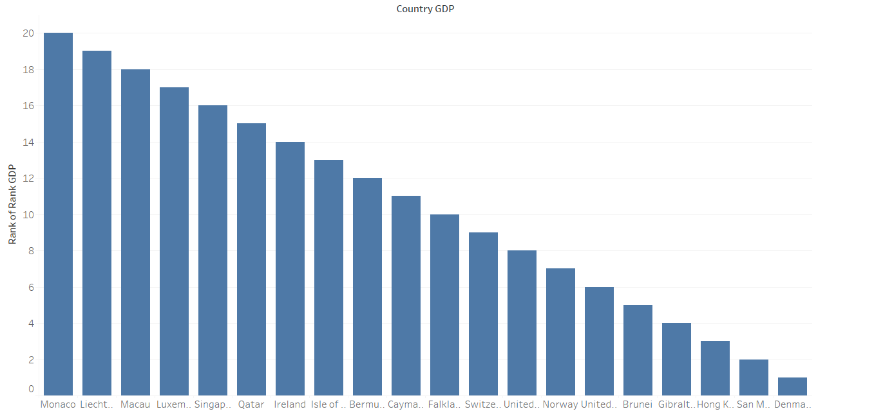

1. Build your dashboard.

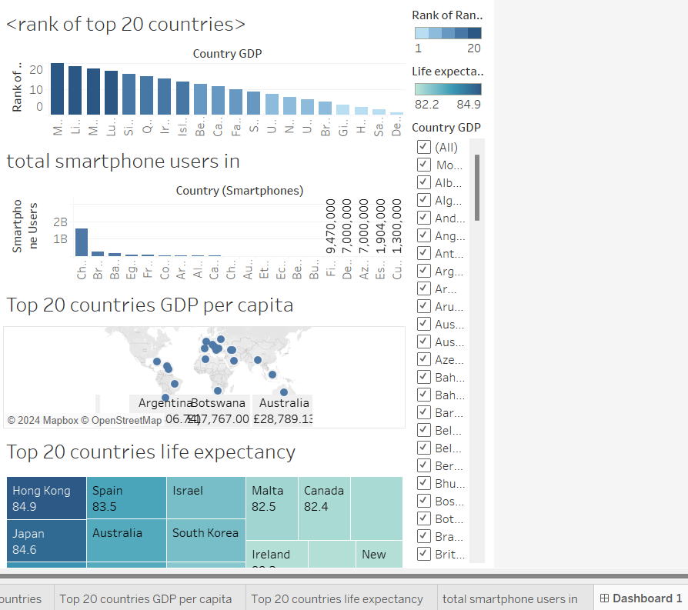

At the bottom of the screen select the Dashboard + tab to create a dashboard, drag and drop the created sheets onto the blank sheet as well as creating the appropriate legends.